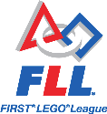
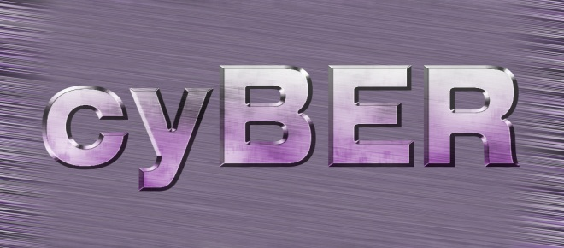
Community – Youth Beloit Engineering Robots

Share this flyer with your parents!

What cyBER is about:

Beloit Memorial High School is very excited to begin an after school
robotics program for our middle school students. This year, we are attempting to create three (3) FIRST Lego League (FLL) teams. Each team can have four to ten students and will have a lead advisor/coach and high school student mentors to work with. The team builds and programs a robot made of Lego Mindstorms (EV3) to perform a series of tasks. The team then travels to a competition, competing with other teams from around the state (or elsewhere) in early November to see whose robot performs the tasks best.

What is FIRST Lego League?

FIRST stands for “For Inspiration and Recognition of Science and Technology”. The organization was founded in 1989 by inventor Dean Kamen to help students

Apply real-world math and science concepts
Create student enthusiasm for technology
Learn critical thinking, team-building and presentation skills
Participate in tournaments and celebrations

Visit: WWW.USFIRST.ORG for more information about FIRST Lego League or view FLL competition videos on U-Tube.

Visit: WWW.beloitcyber.weebly.com for more information on Beloit cyBER.

If your child is interested and you are interested in having your child participate, please fill out the form below and return it to your school’s principal. We will contact you with more information.

Please Print

Name of parent: _____________________________________

Name of child: ______________________________________

phone#: ____________________ email: _________________________

